宁波迪高进出口有限公司
NINGBO DECO IMP. & EXP. CO., LTD.

电放保函
SURRENDER OF ORIGINAL BILL OF LADING

船名/航次： FESCO VOYAGER 086
(Vessel/Voyage.)
提单号： FNVOT96776
(B/L no.)
装运港： NINGBO
(Port of loading)
目的港： VOSTOCHNY
(Port of discharge)
货物名称： CONCRETE VIBRATOR
VIBRATOR HEAD
FLEX HOSE WITH FLEX SHAFT
(Description of Goods)
箱号： MISU2330648 MISU2330817
(Container no.)

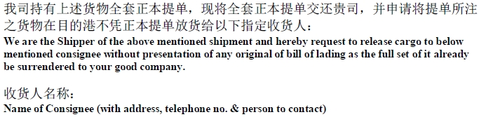

PNEUMATIC GROUP CO. LTD.
174B FURMANOVA STR.,
050010 ALMATY REPUBLIC OF KAZAKHSTAN
PH. / FAX + 7 727 260 10 11
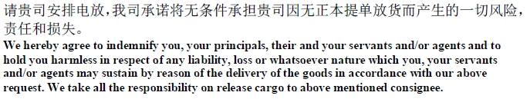
发货人签章处： 订舱代理签章处：
Shipper’s signature (with company’s stamp) Forwarder’s signature (with company’s stamp)

日期： 2011-10-19
Issue date

